Assignment 1 (BIT 102)

Daenise Tan Hooi Qing (B1601153)

Adrian Foo Jun Wei (B1600693)

1. Introduction

The purpose of this site is to provide information for people who believe and interested in horoscope. According to horoscope, it can show a related person’s basic characteristics, preference, flaws and fears. It can also show the strengths and weakness of the twelve horoscopes and also about their health, love, money and career.

We are expecting to have our website to be a complete and attractive website so that any age of people would like to visit our website. Besides, we would like to have our website to be famous and be confirmed by other readers.

As we are creating the website first time, we don’t have constant readers to visit our pages. A lot of similar website has also been published to the internet and it might cause our website difficult to be found. Furthermore, we are facing problem of lack of related information for our website.

1. Target audience

Our intended audience are very wide range. Our audience mainly are people interested or believe in horoscopes and their age are from age 13 to age 65. Our target audience mostly are young and connected female that interested in lifestyle, health, love, career and entertainment information.

1. 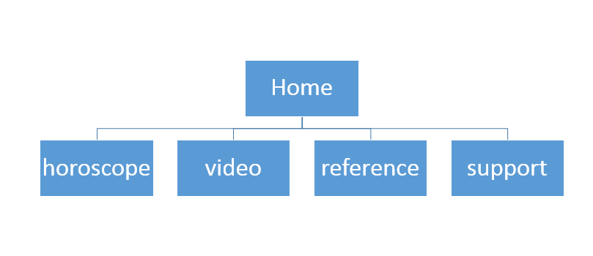Site Map/Story board

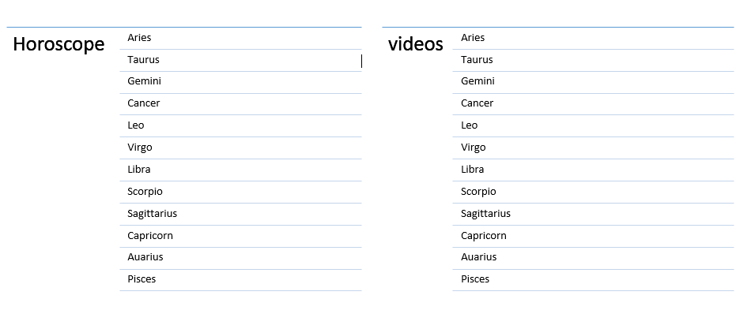

1. Content

Our website will be using Jokerman, Arial or some other embedding font as our font type and we will use monospace as our font family category. For the graphics, we will insert the 12 horoscope picture and may also insert some related animation to our website. The background will be some stars and we will obtain some related videos from other sources to put into it. Some audio files will also be insert if it is possible.

1. 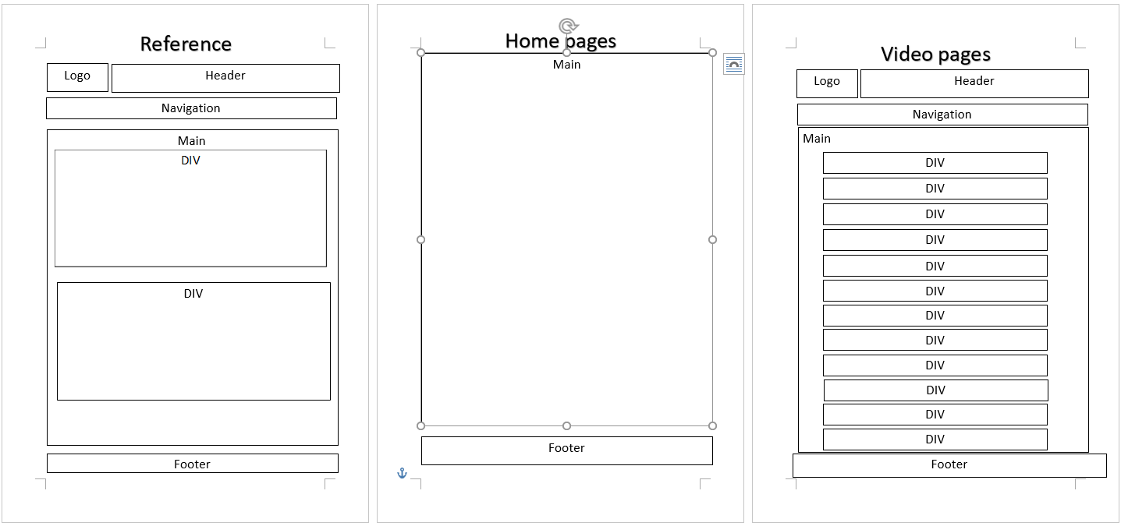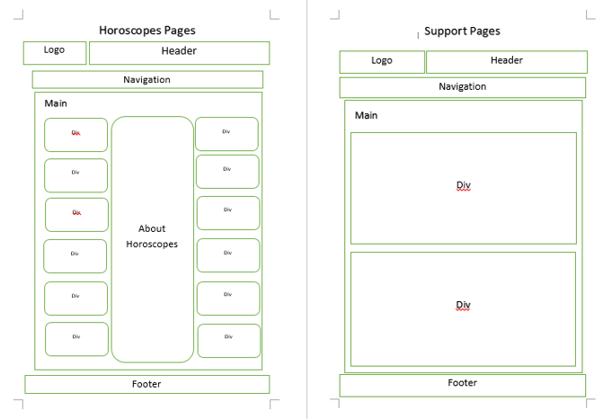Wireframe
2. Related or similar website
3. 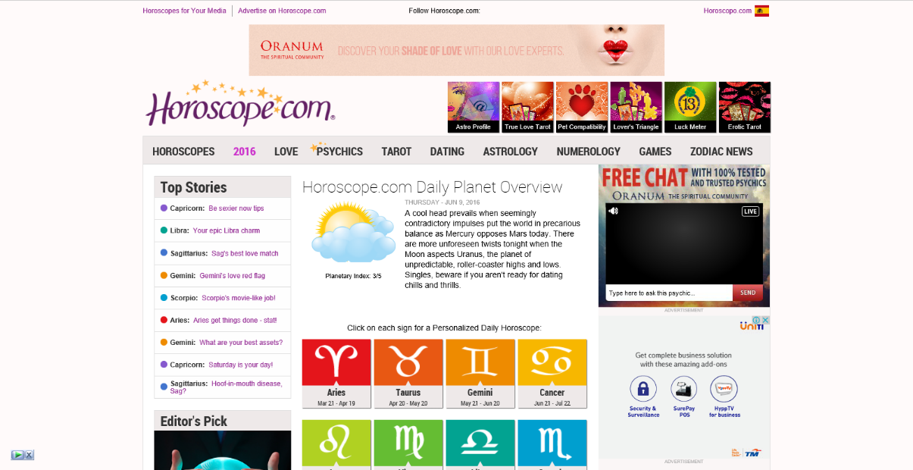<http://www.horoscope.com/us/index.aspx>

This website does not only contain information about horoscope but also contain some others material such that numerology, physics, tarot and dating. Although it has a lot of material provided to the readers, but those advertisements are very annoying. Besides, their website design is too simple and may be improved.

1. 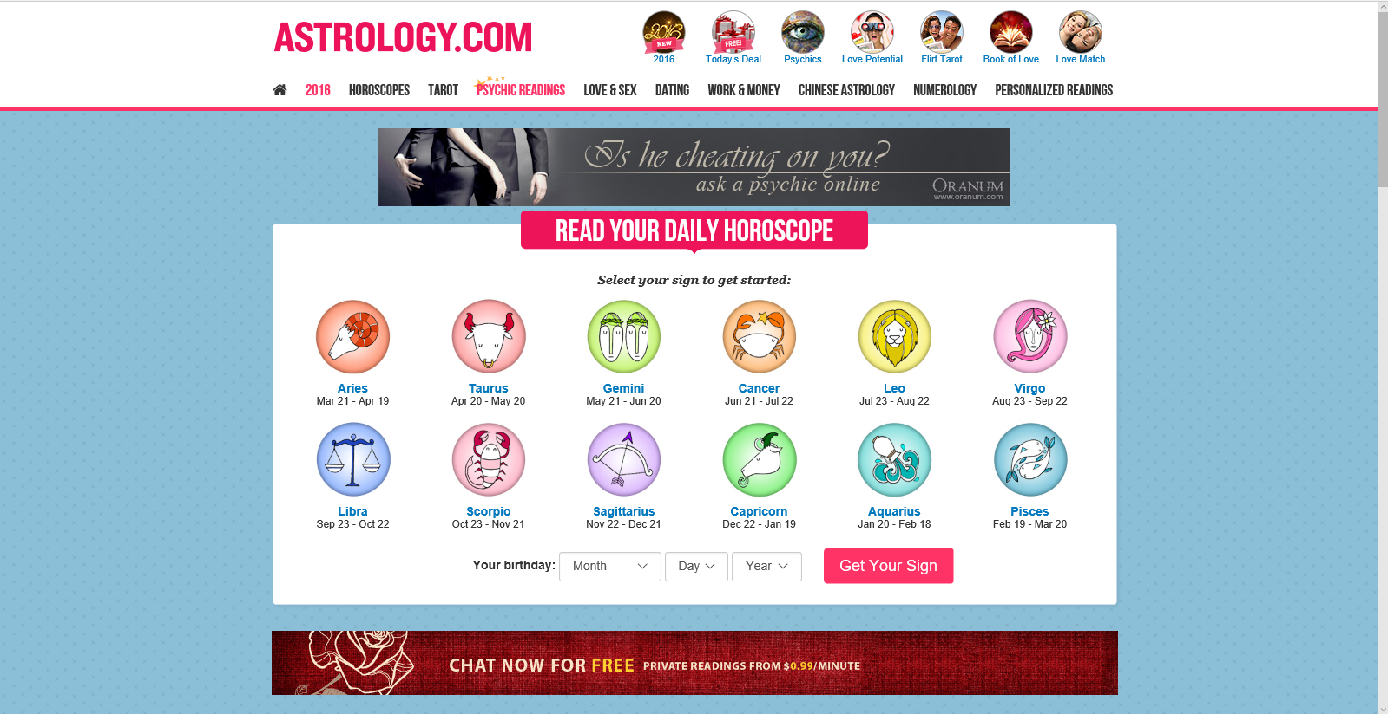<http://www.astrology.com/>

This website is simple and tidy and it is easy to find what we want and it also contain a lot of other materials besides horoscope. The only problem is a lot advertisement under the main body and readers might feel annoying.

1. Content Description
2. Home

Our website title will be displayed and there is another link (get started) will link the home page to horoscope page.

1. Horoscope

There will be 12 links of the horoscope that will link it to relative website and the center of the website will be “about horoscope”.

-About Horoscopes:

* + There are **12 zodiac signs** that are Aquarius,Pisces, Aries, Taurus, Gemmini, Cancer, Leo, Virgo, Libra, Scorpio, Sagittarius, Capricorn. Each sign has its own strengths and weaknesses, its own specific traits, desires and attitude towards life and people. This 12 zodiac signs is based on the date and month of birth. Astrology can give us a glimpse of a person's basic characteristics, preferences, flaws and fears based on their date and month of birth.We made you to find out which is your zodiac sign and know yur characteristics, fortune, profile and love compatibility.

|  |  |  |
| --- | --- | --- |
| Name | Symbol | Date |
| Aries | Aries | 21 March –20 April |
| Taurus | Taurus | 21 April –21 May |
| Gemini | Gemini | 22 May –21 June |
| Cancer | Cancer | 22 June –22 July |
| Leo | Leo | 23 July –22 August |
| Virgo | Virgo | 23 August –23 September |
| Libra | Libra | 24 September –23 October |
| Scorpio | Scorpio | 24 October –22 November |
| Sagittarius | Sagittarius | 23 November –21 December |
| Capricorn | Capricornus | 22 December –20 January |
| Aquarius | Aquarius | 21 January –19 February |
| Pisces | Pisces | 20 February –20 March |

**We are going to write about the date of birth, characteristics, personal life, love, matching horoscopes, money and career of 12 horoscopes as shown on below in our website. **

1. Aquarius Horoscope

* Date : 21 January –19 February
* Characteristics :   
  Aquarius are born shy and quiet. Aquarius is very independent, they needs freedom and dislike people to restrict them. They are very sensitive to surroundings and people. They don’t like to changes too often and they are very straight forward people. They are very intelligent as they can learn things very fast.
* Personal Life :  
   Aquarians are a good communicators, they can mix with all kinds of friends. Their thinking is very crative and progressive. They take interest in everything around them, so they feel difficult to focus on one things.
* Love :  
   Aquarius wants an interesting conversation with their partner. They always imagine their 100% partner and search for him/her. Aquarians also very sensitive in relationship.
* Matching horoscope :   
  Gemini, Libra, Sagittarius
* Money & Career :  
  Aquarius is visionary type that like to participate in activity. They like to show their talents in work or in group. They are good to be a leader in a group. Aquarius can control their daily spending and income so they can maintain their money equally.

1. Pisces Horoscope

Date : 20 February –20 March

Characteristics :

Personal Life :

Love :

Matching horoscope :

Money & Career :

1. Aries Horoscope

Date : 21 March –20 April

Characteristics :

Personal Life :

Love :

Matching horoscope :

Money & Career :

1. Taurus Horoscope

Date : 21 April –21 May

Characteristics :

Personal Life :

Love :

Matching horoscope :

Money & Career :

1. Gemmini Horoscope

Date : 22 May –21 June

Characteristics :

Personal Life :

Love :

Matching horoscope :

Money & Career :

1. -Cancer Horoscope

Date : 22 June –22 July

Characteristics :

Personal Life :

Love :

Matching horoscope :

Money & Career :

1. Leo Horoscope

Date : 23 July –22 August

Characteristics :

Personal Life :

Love :

Matching horoscope :

Money & Career :

1. -Virgo Horoscope

Date : 23 August –23 September

Characteristics :

Personal Life :

Love :

Matching horoscope :

Money & Career :

1. -Libra Horoscope

Date : 24 September –23 October

Characteristics :

Personal Life :

Love :

Matching horoscope :

Money & Career :

1. Scorpio Horoscope

Date : 24 October –22 November

Characteristics :

Personal Life :

Love :

Matching horoscope :

Money & Career :

1. Sagittarius Horoscope

Date : 23 November –21 December

Characteristics :

Personal Life :

Love :

Matching horoscope :

Money & Career :

1. Capricorn Horoscope

Date : 22 December –20 January

Characteristics :

Personal Life :

Love :

Matching horoscope :

Money & Career :

-“Video” about :

-Aquarius Horoscope

- Pisces Horoscope

- Aries Horoscope

- Taurus Horoscope

- Gemmini Horoscope

- Cancer Horoscope

- Leo Horoscope

- Virgo Horoscope

- Libra Horoscope

- Scorpio Horoscope

- Sagittarius Horoscope

- Capricorn Horoscope

C) Reference page

There will be 2 link (with website thumbnails) that will link to others website so that the readers can have alternative source to check their daily or weekly horoscopes. These are the following 2 links:

1. <http://www.elle.com/horoscopes/daily/>
2. <http://www.horoscope.com/us/index.aspx>

D) Support page

There will be some Q&A question and also our contact information so that the readers can contact or providing us for further information.

1. Obtain Contents
2. <https://en.wikipedia.org/wiki/Main_Page>

• Wikipedia have many information about horoscopes.

1. <https://www.youtube.com/>  
    • We extract some video from Youtube  
    • There are some interesting video about horoscopes and zodiac in Youtube.
2. <http://www.deviantart.com/>  
    • This website have many simple and nice pictures.  
    • It let us have idea about our background design.
3. <https://developers.google.com/fonts/docs/getting_started>  
   • We get our font from this website.

9. Reference List

-- (Horoscope, t.t)

-- (Astrology, t.t)